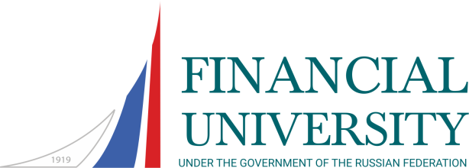
Master Degree Programme

Discipline | Semester (Fall/Summer) | Credits  (ECTS) | Total hours | Hours in class | Exam
Professional Business Ethics | F | 4 | 144 | 40 | +
Development Economics | F | 3 | 108 | 54 | +
International Banking | F | 4 | 144 | 40 | +
International Corporate and Business Law | F | 3 | 108 | 32 | +
International Financial Management | F | 3 | 108 | 30 | +
Management Accounting (an advanced course) | F | 3 | 108 | 30 | +
International Taxation | F | 3 | 108 | 40 | +
International Financial Markets | F | 3 | 108 | 40 | +
Electives (students need to choose one course from two):  International Financial Analysis | F | 3 | 108 | 40 | +
International Portfolio Investment | F | 3 | 108 | 40 | +
Electives (students need to choose one course from two):  International Best Practices in Project Financing | F | 3 | 108 | 30 | -
International Financial Marketing | F | 3 | 108 | 30 | -
Electives (students need to choose one course from two):  Information Trade Systems in International Business | F | 3 | 108 | 30 | -
Transborder Capital Movement on the International Financial Market | F | 3 | 108 | 30 | -
Financial Reporting | F-S | 4 | 144 | 64 | +
Financial and Monetary Methods of Economy Regulation | S | 6 | 216 | 62 | +
Corporate Finance (an advanced course) | S | 4 | 144 | 54 | +
Econometric Research | S | 4 | 144 | 32 | +
Mathematical Support for Financial Decision-Making Process | S | 4 | 144 | 40 | +
Electives (students need to choose one course from two):  International Audit | S | 3 | 108 | 40 | -
Risk-management, financial derivatives | S | 3 | 108 | 40 | -

