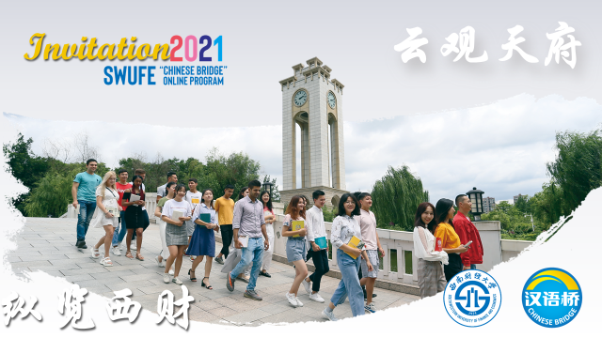

Now a new round of 2021 SWUFE "Chinese Bridge" Delegation Online Program is relaunched this Fall! Overseas students could learn Chinese courses online, experience Chinese culture and Chinese life for FREE during this program. We sincerely invite students to apply for our program. Because this program has limited quota of participants, applicants will be admitted base on the principle of “First Come, First Served” according to the online application submission status.
For any question, applicants may also contact the program coordinator directly via international@swufe.edu.cn.
Brief Introduction
This program period is from Nov.21, 2021 to Dec. 3, 2021 (2 weeks). In this program, a series of language courses and cultural activities will be presented online. We will take "real-time teaching + online activities + video courses+ online tutoring" as the online learning method.
Program Features
SWUFE "Chinese Bridge" Delegation Online Program is unfolded here, in Chengdu, one of China's most well-being cities. In this program, you will:
-Learn real-time language courses based on your Chinese level, such as General Chinese and Business Chinese;
-Experience sites of Chengdu through our camera lens;
-"Wear" Chinese traditional costumes to visit the former residence of a famous Chinese ancient poet -Du Fu's Thatched Cottage;
-Take a trip of Chengdu- Ancient Shu, Breath of Life and Sense of Modern to experience two layers of Chengdu city- the modern urban landscape and historical view.
-Video courses such as visiting Chengdu Panda Base and DIY Sichuan cuisine will also be presented.
There are more surprises awaiting you!
Inquiry Contact
international@swufe.edu.cn
+86-28-87355437
Application Deadline
There is no application fee. Application deadline is Nov. 20, 2021. All non-Chinese citizens are eligible for the application. Please click the the link: https://www.wjx.top/vj/mWHUccl.aspx or scan the attached QR code attached for online application. The whole application procedures may take about 5 minutes.
